Introduction to Video
Video is a sequence of still images (frames) displayed rapidly to create the illusion of continuous motion. This phenomenon occurs because of persistence of vision, where the human eye briefly retains an image (about 1/16 second) after it disappears. When images are shown quickly enough, the brain perceives smooth motion instead of separate pictures.

Definition
Video is a collection of sequential images (frames), synchronized with audio when required, that creates the perception of moving visual scenes.

1. Digital Video

Definition
Digital video is a sequence of digital images (frames) displayed rapidly to create the illusion of motion. Each frame is a still image, and when frames are displayed continuously (typically 24–60 frames per second), the human eye perceives smooth movement.
Digital video is the electronic representation of moving images where each frame is stored as binary data (0s and 1s). It can be processed, edited, compressed, transmitted, and displayed using computer systems.
Unlike analog video, digital video stores visual information numerically, making it more suitable for modern multimedia applications.

Components of Digital Video
- Frames: Individual images in a video.
- Frame Rate (fps): Number of frames displayed per second (e.g., 24 fps, 30 fps, 60 fps).
- Resolution: Number of pixels in each frame (e.g., 1280×720, 1920×1080).
- Color Depth: Number of bits used to represent colors.
- Bit Rate: Amount of data processed per second (kbps or Mbps).

Digital Video Components
Every digital video consists of several components.

A. Frames
A frame is a single still image in a video sequence.
Example:
A 10-second video recorded at 30 fps contains:
10×30=300 frames
Each frame contributes to the illusion of continuous motion.

B. Pixels
A pixel (Picture Element) is the smallest addressable unit of a digital image.
For a resolution of:
1920 × 1080
Total pixels:
1920×1080=2,073,6001920
Approximately 2.07 megapixels.

C. Resolution
Resolution specifies the number of pixels displayed horizontally and vertically.
Higher resolution generally provides greater detail but also increases storage and bandwidth requirements.
Resolution | Dimensions | Common Name
640 × 480 | VGA | Standard Definition
1280 × 720 | HD | High Definition
1920 × 1080 | Full HD | Full High Definition
2560 × 1440 | QHD | Quad HD
3840 × 2160 | 4K UHD | Ultra HD
7680 × 4320 | 8K UHD | Ultra High Definition

D. Frame Rate (Frames Per Second)
Frame rate indicates the number of frames displayed every second.

Formula

FPS=Number of Frames/Time

​ Common Frame Rates
FPS | Applications
24 | Cinema
25 | PAL television
30 | NTSC/web video
50 | Sports broadcasting
60 | Gaming, sports, smooth motion
120+ | Slow-motion capture and high-performance gaming
Higher frame rates produce smoother motion but require more processing power and storage.

E. Aspect Ratio
Aspect ratio is the proportional relationship between the width and height of a video.

Formula
Aspect Ratio=Width/Height

Common Aspect Ratios
Aspect Ratio | Applications
4:3 | Older televisions and monitors
16:9 | HDTV, YouTube, streaming
21:9 | Cinema, ultrawide displays
1:1 | Social media posts
9:16 | Vertical smartphone videos

F. Bit Depth
Bit depth determines how many colors can be represented for each pixel.

Formula
Colors=2^n
Where n is the number of bits.
Bit Depth | Possible Colors
8-bit | 256 values per channel
24-bit RGB | About 16.7 million colors
30-bit RGB | About 1.07 billion colors
Higher bit depth allows smoother gradients and more accurate color reproduction.

G. Bit Rate
Bit rate is the amount of data processed or transmitted each second.

Unit
- kbps (kilobits per second)
- Mbps (megabits per second)
Higher bit rates usually improve quality but increase file size.
Example:
- 5 Mbps → Standard HD streaming
- 25 Mbps → Typical 4K streaming

Characteristics of Digital Video
- Stored as binary data.
- High image quality.
- Easy to edit and process.
- Supports compression.
- Efficient transmission over networks.
- Can include synchronized audio, subtitles, and metadata.
- Compatible with streaming platforms.

Analog Video vs Digital Video
Feature | Analog Video | Digital Video
Representation | Continuous electrical signal | Binary data
Noise | More susceptible | Less susceptible
Editing | Difficult | Easy
Storage | Magnetic tape | Hard disks, SSDs, cloud
Transmission | Signal quality degrades | Can be copied without cumulative quality loss
Compression | Limited | Extensive codec support
Cost | Older technology | Widely used today

Advantages of Digital Video
- High picture quality.
- Easy editing and post-production.
- Efficient compression reduces storage needs.
- Supports online streaming.
- Can be copied repeatedly with minimal quality degradation.
- Compatible with AI-based video analysis.

Limitations of Digital Video
- High-resolution videos require substantial storage.
- Editing and rendering demand powerful hardware.
- Large files require higher network bandwidth.
- Compression artifacts may appear when bit rates are too low.

Applications
- Online streaming (YouTube, Netflix)
- Video conferencing
- Digital television
- E-learning
- Entertainment and gaming

2. Video Signal Representation

Definition
Video signal representation is the process of representing visual information electronically so that it can be stored, transmitted, and displayed.
There are two major types:

A. Analog Video Signal
- Continuous electrical signal
- Used in traditional television systems
- Examples:
  - NTSC
  - PAL
  - SECAM

Characteristics
- Susceptible to noise
- Lower picture quality
- Difficult to edit

NTSC (National Television System Committee)

Definition
NTSC is the first widely adopted analog color television standard, developed by the National Television System Committee in the United States in 1953. It was designed to provide color television while remaining compatible with existing black-and-white TVs.

Features
- Frame Rate: 30 frames per second (actually 29.97 fps)
- Fields per Second: 60
- Resolution: 525 scan lines
- Frequency: 60 Hz
- Color Encoding: Uses the YIQ color model

PAL (Phase Alternating Line)

Definition
PAL is an analog color television standard developed in Germany by Walter Bruch in 1963. It improves color accuracy by automatically correcting color errors during transmission.

SECAM (Sequential Color with Memory)

Definition
SECAM is an analog color television standard developed in France in 1967. Unlike NTSC and PAL, SECAM transmits color information sequentially and uses memory in the television receiver to reconstruct the full-color image.

B. Digital Video Signal
- Represents video as binary data (0s and 1s).
- Used in modern multimedia systems.

Digital Video Representation
Each video consists of:
Video
↓
Frames
↓
Pixels
↓
Binary Values
Example:
Video
Frame 1
Frame 2
Frame 3
...
Frame n
Each frame contains thousands or millions of pixels.

Color Representation
Each pixel is represented using RGB values.
Example:
Pixel | RGB Value
Red | (255,0,0)
Green | (0,255,0)
Blue | (0,0,255)

3. Computer Video Format

Definition
A computer video format specifies how video data is stored, compressed, and played on computer systems.
It includes:
- Video codec
- Audio codec
- File container

Common Video Formats
Format | Extension | Features
MP4 | .mp4 | Most popular, high compression
AVI | .avi | High quality, larger file size
MOV | .mov | Apple QuickTime format
WMV | .wmv | Microsoft Windows Media
MKV | .mkv | Supports multiple audio/subtitle tracks
FLV | .flv | Adobe Flash Video
WebM | .webm | Used for web streaming

Video Compression Standards
Codec | Description
H.264 | Widely used, efficient compression
H.265 (HEVC) | Better compression than H.264
VP9 | Open-source codec by Google
AV1 | Modern royalty-free codec

Factors Affecting Video Size
- Resolution
- Frame rate
- Color depth
- Bit rate
- Compression method

4. Computer-Based Animation

Definition
Computer-based animation is the process of creating moving images using computer software by displaying a sequence of images.
Animation creates the illusion of movement by rapidly displaying slightly different images.

Working Principle
Object Creation
↓
Key Frames
↓
Intermediate Frames (Tweening)
↓
Animation Playback

Computer-Based Animation

Introduction
Computer-based animation is the process of creating the illusion of movement by displaying a sequence of images (frames) in rapid succession. Instead of drawing every frame manually, modern animation software allows animators to define the important positions of an object, and the computer automatically generates the remaining frames. This process saves time, reduces effort, and produces smooth, realistic animations.
The working principle of computer-based animation consists of four major stages:
Object Creation
↓
Key Frames
↓
Intermediate Frames (Tweening)
↓
Animation Playback

1. Object Creation

Definition
Object creation is the first step in animation, where the animator designs or imports the objects that will appear in the animation. These objects can be simple shapes (circles, rectangles), text, images, characters, vehicles, or complex 3D models.
The object is the element that will be animated by changing its position, size, rotation, color, or other properties over time.

Activities Performed
- Designing the object
- Selecting colors and textures
- Defining object size and shape
- Positioning the object on the screen
- Setting initial properties (location, opacity, scale)

Example
Suppose we want to animate a car moving from the left side of the screen to the right.
Initially, the animator creates or imports the car model and places it at the starting position.
Time = 0 second
+---------------------------------------------+
| 🚗 |
| |
| |
+---------------------------------------------+

Common Software Used
- Adobe Animate
- Blender
- Autodesk Maya
- Unity
- Unreal Engine

2. Key Frames

Definition
A key frame is an important frame that defines the starting, ending, or significant position of an object during an animation. Instead of specifying every frame, the animator only defines these important moments.
The computer uses these key frames as reference points to generate the remaining frames automatically.

Purpose of Key Frames
Key frames specify changes such as:
- Position
- Rotation
- Size (Scaling)
- Color
- Opacity
- Shape

Example
Suppose a ball moves from the left side of the screen to the right in 5 seconds.
Key Frame 1 (Start):
Time = 0 sec
⚽
Key Frame 2 (End):
Time = 5 sec
⚽
Only these two positions are defined by the animator.

Advantages
- Reduces manual work.
- Easy to modify the animation.
- Provides better control over motion.
- Speeds up animation development.

3. Intermediate Frames (Tweening)

Definition
Tweening (short for in-betweening) is the process in which the computer automatically generates the intermediate frames between two key frames.
Instead of drawing every frame manually, the animation software calculates the object's position, size, rotation, and other properties for each intermediate frame.

Working Process
Suppose an animation runs at 30 frames per second (fps) and lasts 2 seconds.
Total frames:
30 × 2 = 60 frames
If:
- Frame 1 is the starting key frame.
- Frame 60 is the ending key frame.
The computer automatically generates:
Frames 2–59.

Example
A ball moving horizontally:
Frame 1
⚽
Frame 15
⚽
Frame 30
⚽
Frame 45
⚽
Frame 60
⚽
Only Frame 1 and Frame 60 are key frames. All other frames are created automatically.

Types of Tweening

A. Motion Tweening
Changes the object's position.
Example:
🚗 ---------------------------->

B. Shape Tweening
Changes one object into another.
Example:
○ → □

C. Color Tweening
Gradually changes colors.
Example:
Red → Orange → Yellow → Green

D. Scale Tweening
Changes object size.
Example:
Small Circle → Medium Circle → Large Circle

E. Rotation Tweening
Rotates an object smoothly.
Example:
0° → 90° → 180° → 270°

Advantages of Tweening
- Produces smooth animation.
- Saves significant time.
- Requires fewer manually drawn frames.
- Makes movement more natural and realistic.

4. Animation Playback

Definition
Animation playback is the final stage where all generated frames are displayed continuously at a specified frame rate to create the illusion of motion.
The animation software rapidly displays one frame after another, making static images appear as moving objects.

Frame Rate
Frame rate determines how many frames are displayed every second.
Frame Rate | Application
24 fps | Movies
25 fps | Television (PAL)
30 fps | Online videos
60 fps | Gaming and sports
Higher frame rates result in smoother animations but require more processing power and storage.

Playback Example
Frame 1 🚗
Frame 2 🚗
Frame 3 🚗
Frame 4 🚗
Frame 5 🚗
Since these frames are displayed very quickly, the car appears to move smoothly across the screen.

During Playback
The computer performs the following tasks:
- Displays frames in sequence.
- Maintains the specified frame rate.
- Synchronizes audio with video.
- Renders lighting, textures, and visual effects (for 3D animation).
- Handles user interaction in interactive applications (e.g., games).

Complete Animation Process
Step 1
Create Object
│
▼
Design a character, car, ball, logo, or any object.
│
▼
Step 2
Create Key Frames
│
▼
Define the object's important positions and transformations.
│
▼
Step 3
Tweening
│
▼
The computer automatically generates intermediate frames.
│
▼
Step 4
Playback
│
▼
Frames are displayed rapidly to create smooth motion.

Real-Life Example
Suppose you are creating an animation of a bird flying across the sky.

Step 1: Object Creation
Create or import the bird image.
🐦

Step 2: Key Frames
- Key Frame 1: Bird on the left side.
- Key Frame 2: Bird on the right side.
Time = 0 sec 🐦
Time = 5 sec 🐦

Step 3: Tweening
The software generates all intermediate positions automatically.
🐦 → 🐦 → 🐦 → 🐦

Step 4: Playback
The generated frames are displayed at 30 fps, making the bird appear to fly smoothly across the screen.

Advantages of This Animation Process
- Saves time and effort.
- Produces smooth and realistic movement.
- Simplifies editing by modifying only key frames.
- Reduces manual drawing of every frame.
- Supports complex effects such as scaling, rotation, fading, and color changes.

Applications
- Animated movies and cartoons
- Video games
- Mobile applications
- Website animations
- Educational simulations
- Scientific visualization
- Advertising and marketing
- User interface (UI) animations

Summary
The working principle of computer-based animation involves four sequential stages:
- Object Creation: Create or import the object to be animated.
- Key Frames: Define the important positions or transformations of the object.
- Intermediate Frames (Tweening): Automatically generate the in-between frames to create smooth transitions.
- Animation Playback: Display all frames rapidly (e.g., 24–60 fps) to produce the illusion of continuous motion.

Types of Computer Animation

A. 2D Animation
Objects move in two dimensions (X and Y).
Examples:
- Cartoons
- Educational videos

B. 3D Animation
Objects move in three dimensions (X, Y, and Z).
Examples:
- Animated movies
- Video games
- Product visualization

C. Motion Graphics
Animated text, logos, and graphical elements.
Applications:
- Advertisements
- News broadcasts
- Title sequences

D. Stop Motion Animation
Creates animation by photographing physical objects frame by frame.

Animation Techniques

1. Frame-by-Frame Animation
Each frame is drawn individually.

2. Keyframe Animation
Animator specifies important frames, and the computer generates intermediate frames (tweening).

3. Procedural Animation
Movement is generated using mathematical algorithms or physics simulations.

Applications
- Gaming
- Movies
- Medical visualization
- Education
- Scientific simulations
- Advertising

5. Animation Language

Definition
An animation language is a programming or scripting language used to define, control, and create animations.
It specifies:
- Object movement
- Rotation
- Scaling
- Timing
- Color changes
- Interaction

Basic Components of Animation Language

1. Objects
Elements to be animated.
Example:
- Circle
- Car
- Human character

2. Motion Commands
Examples:
- Move
- Rotate
- Scale
- Translate
- Zoom

3. Timing Control
Specifies:
- Start time
- End time
- Speed
- Delay
Example:
Move Object
Start = 2 sec
End = 5 sec

4. Transformation
Changes object properties:
- Position
- Size
- Rotation
- Color

Common Animation Languages and Technologies
Language/Technology | Purpose
JavaScript | Web animations
CSS Animations | Web page effects
SVG Animation | Vector graphics animation
Adobe Animate (ActionScript) | Interactive animations
Python (Pygame, Manim) | Educational and scientific animations
Unity C# | Game animations
Unreal Engine Blueprints/C++ | 3D game animations

Advantages of Animation Languages
- Automate animation creation
- Reusable animation scripts
- Interactive animations
- Faster development
- Better control over movement and timing

Timeline and Frame-Based Animation

Learning Objectives
After studying this chapter, students will be able to:
- Define Timeline and Frame-Based Animation.
- Explain the concept of Timeline.
- Describe Frames and Keyframes.
- Calculate and interpret Frame Rate (FPS).
- Understand Onion Skinning.
- Create simple frame-by-frame animations.
- Compare frame-based animation with tween-based animation.
- Explain practical applications in multimedia, gaming, education, and film.

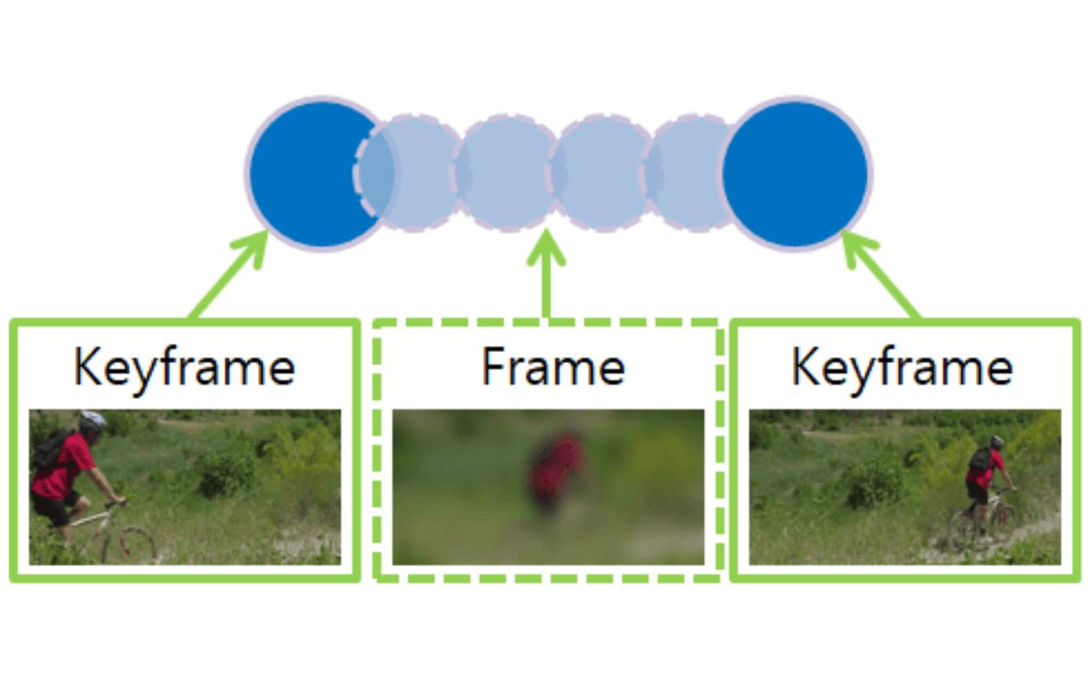
6

Comparison: Frame-Based vs Tween-Based Animation
Feature | Frame-Based Animation | Tween-Based Animation
Frame Creation | Every frame is drawn manually | Only keyframes are created; software generates intermediate frames
Time Required | High | Lower
Flexibility | Very high | Moderate
Best For | Character animation, cartoons, artistic motion | Logos, UI effects, object movement
Software Automation | Minimal | Extensive

Summary
Concept | Description
Timeline | Organizes frames over time and controls animation duration
Frame | A single still image in an animation sequence
Keyframe | A frame marking a significant change in an object's properties
Frame Rate (FPS) | Number of frames displayed each second
Onion Skinning | Displays neighboring frames transparently to assist smooth animation
Frame-Based Animation | Animation method where each frame is created individually

1. Introduction to Timeline and Frame-Based Animation
Animation is the illusion of movement created by displaying a sequence of images rapidly. In frame-based animation, every frame is created or edited individually. These frames are arranged on a timeline, which controls when each frame appears.
Unlike tween-based animation, where software automatically generates intermediate frames, frame-based animation requires the animator to design each frame manually.

Definition
Timeline and Frame-Based Animation is an animation technique in which every frame is individually created and organized on a timeline to produce continuous motion when displayed in sequence.

Animation Workflow
Idea / Storyboard
│
▼
Draw Individual Frames
│
▼
Arrange Frames on Timeline
│
▼
Set Frame Rate (FPS)
│
▼
Preview Animation
│
▼
Edit & Refine
│
▼
Export Animation

Stage 1: Idea / Storyboard

Definition
The Idea stage is the creative planning phase where the animator decides what story or message the animation will communicate. After developing the idea, it is organized into a storyboard, which is a series of sketches showing the sequence of scenes.
A storyboard acts as the blueprint of the animation before production begins.

Objectives
- Define the animation's purpose.
- Plan the storyline.
- Organize scenes logically.
- Reduce production errors.
- Estimate production time and resources.

Storyboard Components
A storyboard typically includes:
- Scene number
- Sketch or illustration
- Description of the action
- Camera movement
- Dialogue or narration
- Sound effects
- Estimated duration

Example Storyboard
Scene | Sketch | Description | Duration
1 | Student enters classroom | Introduction | 3 sec
2 | Teacher starts lecture | Learning begins | 5 sec
3 | Students use computers | Practical session | 6 sec
4 | Class ends | Conclusion | 2 sec

Advantages
- Improves planning.
- Saves production time.
- Helps the team visualize the final animation.
- Identifies mistakes before production.

Real-Life Example
Before producing an animated movie, studios first prepare hundreds or even thousands of storyboard sketches to visualize the complete story before creating the actual animation.

Stage 2: Draw Individual Frames

Definition
After planning, the animator creates each individual frame. A frame is one still image, and many frames displayed rapidly create the illusion of movement.
In frame-by-frame animation, every frame is drawn manually.

Process
- Draw the first frame.
- Draw the next frame with a slight change.
- Continue until the movement is complete.

Example: Moving Ball
Frame 1

O

------------------

Frame 2

O

------------------

Frame 3

O

------------------

Frame 4

O
Each frame moves the ball slightly to the right.

Best Practices
- Keep object proportions consistent.
- Make smooth, gradual movements.
- Use onion skinning to compare adjacent frames.

Applications
- Cartoon animation
- Character animation
- Hand-drawn animation
- Traditional 2D animation

Stage 3: Arrange Frames on Timeline

Definition
After creating the frames, they are placed on the timeline in chronological order. The timeline determines when each frame is displayed.
The timeline acts as the control panel for the animation.

Timeline Example
Time →
-------------------------------------------------

Frame Number

1 2 3 4 5 6 7 8

■──■──■──■──■──■──■──■
Each block represents one frame.

Timeline Functions
- Organizes animation.
- Controls timing.
- Synchronizes audio.
- Supports multiple layers.
- Allows insertion of keyframes.

Multi-Layer Timeline
Background

■■■■■■■■■■■■

Character

■□■□■□■□■□

Text

□□□□■■■■□□
Different elements can be animated independently.

Advantages
- Easy editing.
- Better synchronization.
- Precise timing control.
- Organized workflow.

Stage 4: Set Frame Rate (FPS)

Definition
The Frame Rate specifies how many frames are displayed each second.
It determines the smoothness of the animation.

Formula
FPS=Number of FramesTime (seconds)
FPS= Number of Frames/Time (seconds)

Example 1
Animation Duration = 5 seconds
Frames = 150
FPS=150/5=30FPS
Therefore, the animation runs at 30 FPS.

Example 2
Movie Duration = 120 seconds
FPS = 24
Total Frames
24×120=2880

Common Frame Rates
FPS | Applications
12 | Simple web animations
24 | Cinema
25 | PAL television
30 | Online videos and TV
60 | Gaming and sports
120 | Slow-motion recording

Effect of FPS
Low FPS | High FPS
Choppy movement | Smooth movement
Smaller file size | Larger file size
Lower processing requirements | Higher processing requirements

Stage 5: Preview Animation

Definition
The preview stage allows the animator to play the animation before final production to check whether everything works correctly.
This stage is similar to testing software before release.

What Is Checked?
- Smoothness of movement
- Object positions
- Timing
- Audio synchronization
- Camera movement
- Lighting and colors
- Animation speed

Example
If a character appears to "jump" unexpectedly between frames, the animator can detect the issue during preview instead of after exporting the final animation.

Advantages
- Detects mistakes early.
- Saves rendering time.
- Improves overall quality.
- Ensures synchronization.

Stage 6: Edit & Refine

Definition
After previewing, the animation is improved by correcting errors and enhancing its quality.
This stage is often repeated several times until the animation meets the desired standard.

Editing Activities

A. Correct Drawing Errors
- Fix incorrect shapes.
- Maintain character proportions.

B. Improve Timing
Adjust frame spacing to make movement appear more natural.

C. Modify Colors
Improve brightness, contrast, and color consistency.

D. Add Special Effects
Examples:
- Shadows
- Fire
- Smoke
- Rain
- Motion blur
- Lighting effects

E. Synchronize Audio
Align:
- Background music
- Voice narration
- Sound effects
with the animation.

F. Optimize Performance
- Remove unnecessary frames.
- Compress assets.
- Reduce rendering time.

Example
During preview, a walking character appears to move too quickly.
The animator increases the number of intermediate frames, making the walking motion smoother and more realistic.

Stage 7: Export Animation

Definition
The final animation is converted into a standard file format so it can be viewed, shared, or published.

Common Export Formats
Format | Applications
MP4 | YouTube, websites, social media
MOV | Professional video editing
AVI | Windows multimedia
GIF | Short looping animations
WebM | Web applications
SWF (legacy) | Older web animations

2. Timeline
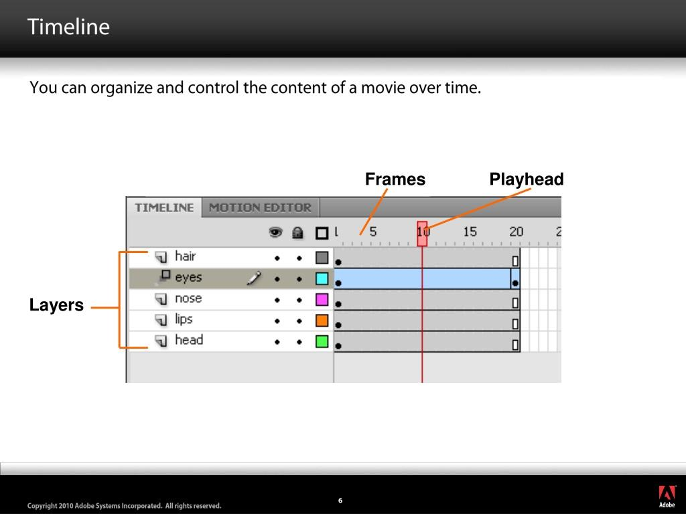

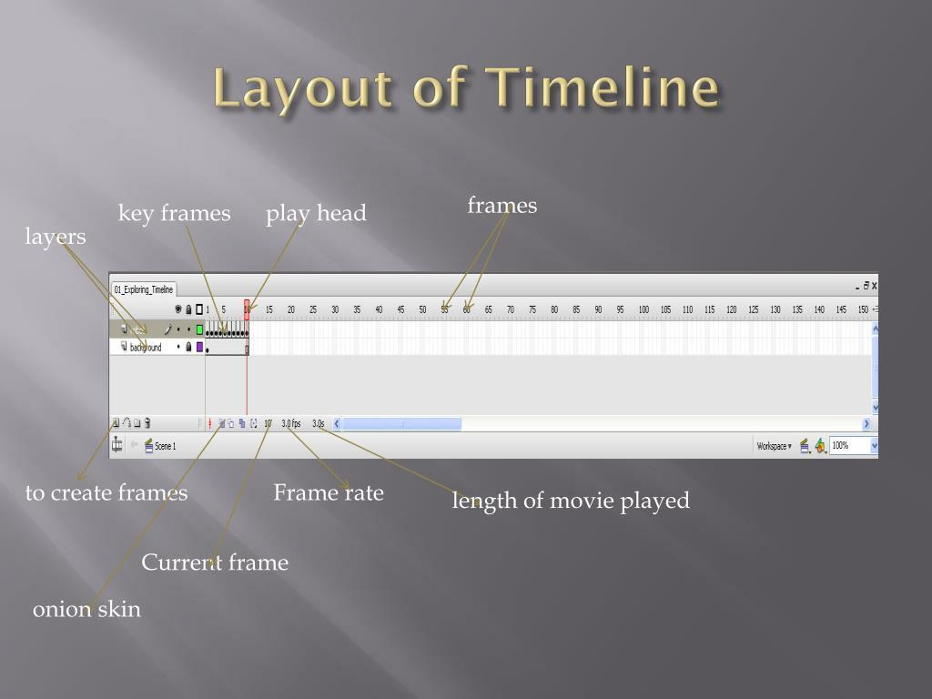
5

Definition
A Timeline is the main workspace used to organize frames over time. It determines when objects appear, move, disappear, or change.
Think of a timeline as the time axis of an animation.

Characteristics of Timeline
- Organizes animation from beginning to end.
- Represents time from left to right.
- Contains frames and keyframes.
- Supports multiple layers.
- Controls animation duration.
- Synchronizes audio and visual elements.

Timeline Components
------------------------------------------------------------>
Time

|1|2|3|4|5|6|7|8|9|10|

Frame Numbers
Each box represents one frame.

Timeline with Layers
Layer 3 |□|□|■|□|□|□|■|
Layer 2 |■|□|□|□|■|□|□|
Layer 1 |■|■|■|■|■|■|■|
1 2 3 4 5 6 7
Where:
- □ = Empty Frame
- ■ = Frame containing content

Advantages of Timeline
- Easy animation management.
- Supports multiple objects independently.
- Allows precise timing.
- Simplifies synchronization.
- Makes editing straightforward.

Applications
- Cartoon production
- Educational videos
- Motion graphics
- Video games
- Web animation

3. Frames

Definition
A Frame is one individual image displayed in an animation sequence.
When multiple frames are shown rapidly, they create the illusion of movement.

Example
Suppose a ball moves from left to right.
Frame 1

O

-----------------------

Frame 2

O

-----------------------

Frame 3

O

-----------------------

Frame 4

O
Each frame shows the ball in a slightly different position.

Types of Frames

A. Empty Frame
Contains no object.
[ ]

B. Static Frame
Object remains unchanged.
[Ball]

C. Content Frame
Contains graphics, text, or animation elements.

D. Blank Keyframe
Used to begin a new animation sequence.

Frame Number
Frames are numbered sequentially.
Example:
1 2 3 4 5 6 7 8 9 10

4. Keyframes
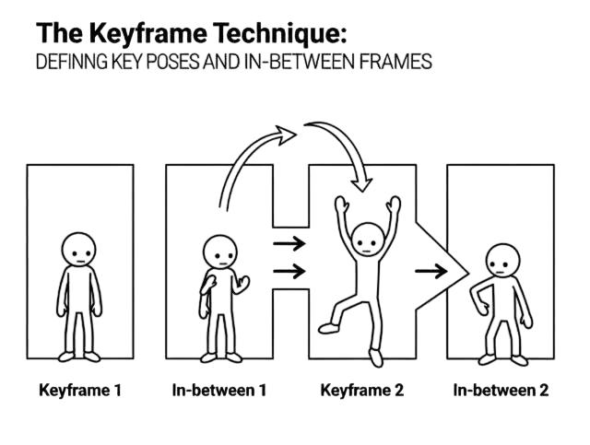
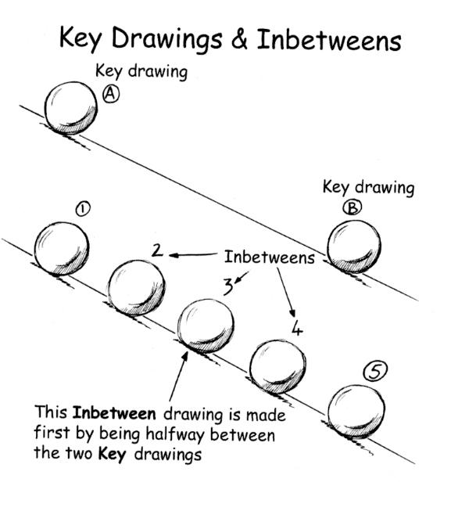
6

Definition
A Keyframe is a special frame where an important change occurs.
Examples of changes include:
- Position
- Rotation
- Scale
- Opacity
- Color
- Shape
The animation software uses keyframes to define major states of an object.

Example
A ball moves across the screen.
Frame 1

●

Keyframe

--------------------

Frame 15

●

Keyframe

--------------------

Frame 30

●

Keyframe
Each keyframe records a significant position.

Types of Keyframes

Position Keyframe
Changes object location.

Rotation Keyframe
Changes object angle.

Scale Keyframe
Changes object size.

Color Keyframe
Changes object color.

Opacity Keyframe
Changes transparency.

Advantages
- Reduces repetitive work.
- Makes editing easier.
- Provides precise control.
- Essential for complex animations.

5. Frame Rate (FPS)

Definition
Frame Rate is the number of frames displayed every second.

Unit
Frames Per Second (FPS)

Formula
FPS=Number of Frames/Time (seconds)

Example 1
Animation Duration = 5 seconds
Frames = 150
FPS=150/5=30FPS
Frame Rate = 30 FPS

Standard Frame Rates
FPS | Applications
12 | Simple web animations
24 | Cinema
25 | PAL television
30 | Television and online videos
60 | Gaming and sports
120 | High-speed recording and slow motion

Effect of Frame Rate
Low FPS | High FPS
Choppy motion | Smooth motion
Less storage | More storage
Lower CPU usage | Higher CPU usage

6. Onion Skinning
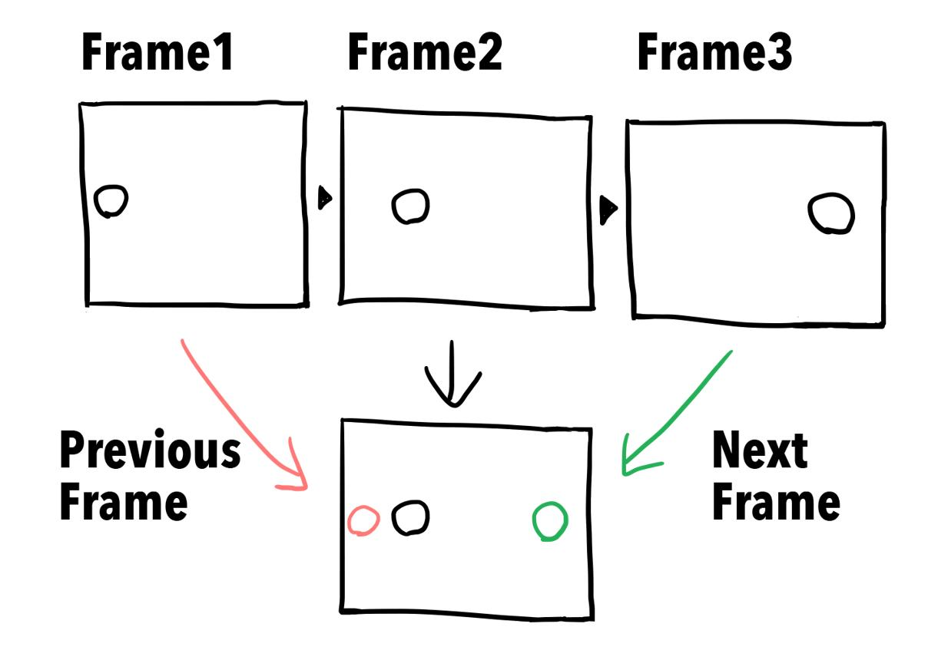

7. Practical Example

Example 1: Bouncing Ball Animation

Frame 1
Ball at the top.
O

__________

Frame 2
Ball moving downward.

O

__________

Frame 3
Ball reaches the ground.

O_________

Frame 4
Ball bounces upward.

O

__________

Frame 5
Ball returns to the top.
O

__________
When these frames are played at 24–30 FPS, the ball appears to bounce naturally.

Example 2: Walking Character
Frame 1
Left foot forward.
Frame 2
Standing position.
Frame 3
Right foot forward.
Frame 4
Standing position.
Repeating these frames creates a continuous walking cycle.

Example 3: Traffic Signal Animation
- Frame 1: Red light ON
- Frame 2: Yellow light ON
- Frame 3: Green light ON
Looping the sequence simulates a working traffic signal.

Frame-Based Animation Process
Idea
│
▼
Storyboard
│
▼
Draw Frame 1
│
▼
Draw Frame 2
│
▼
Draw Frame 3
│
▼
Add Keyframes
│
▼
Arrange on Timeline
│
▼
Set FPS
│
▼
Preview
│
▼
Export

Advantages of Timeline and Frame-Based Animation
- Precise control over every frame.
- Excellent for complex character animation.
- Produces expressive and detailed movement.
- Ideal for cartoons and artistic animation.
- Easy to synchronize with audio.

Disadvantages
- Time-consuming because each frame is created individually.
- Requires skilled animators.
- Large projects involve many frames.
- More editing effort than tween-based animation.
- Increased storage and rendering time for lengthy animations.

Applications
Field | Application
Film Industry | Animated movies and visual effects
Television | Cartoons and advertisements
Education | Interactive learning materials
Gaming | Character and sprite animation
Medicine | Surgical and anatomical visualization
Engineering | Simulation of machines and processes
Scientific Research | Visualization of physical phenomena
Mobile Applications | User interface animations

Part I: Methods of Controlling Animation

What is Animation Control?
Animation control refers to the techniques used to determine how, when, and where an object moves, changes, or interacts during an animation.
Animation control manages:
- Position
- Rotation
- Scale
- Speed
- Direction
- Color
- Opacity
- User interaction

Comparison of Animation Control Methods
Method | Controlled By | Applications
Frame-by-frame | Animator | Cartoons
Keyframe | Animator + Software | Motion graphics
Tween | Software | Advertisements
Script | Programming | Games
Event | User interaction | Interactive media
Time | System clock | Simulations
Physics | Physical equations | Engineering, games
AI | Machine learning | Smart animation

Types of Animation Control

1. Frame-by-Frame Control

Definition
Each frame is created manually by the animator.
Every movement is explicitly defined.
Frame 1 Frame 2 Frame 3

● ● ●
→ →

Characteristics
- Maximum control
- High-quality animation
- Time-consuming
- Suitable for cartoons

Applications
- Disney animation
- Anime
- Traditional cartoons

2. Keyframe-Based Control

Definition
The animator specifies only important frames (keyframes).
The computer automatically generates intermediate frames.
Keyframe

●

↓

Computer generates

● ● ● ● ●

↓

Keyframe

●

Advantages
- Faster production
- Smooth movement
- Easy editing

Example
A car moves from left to right.
- Frame 1 → Left
- Frame 60 → Right
The software generates Frames 2–59.

3. Tween-Based Control
Tween means "in-between."
The software automatically creates intermediate frames.

Types

Motion Tween
Object changes position.
Example:
Logo slides across the screen.

Shape Tween
Object changes shape.
Example:
Circle
↓
Square

Color Tween
Changes color gradually.
Example:
Blue
↓
Green

Opacity Tween
Changes transparency.
Example:
Invisible
↓
Visible

4. Script-Based Control
Animation is controlled using programming languages.
Examples:
- JavaScript
- Python
- C#
- Unity Script

5. Event-Based Control
Animation starts after an event.
Events include:
- Mouse click
- Keyboard press
- Touch
- Voice command

6. Time-Based Control
Animation depends on elapsed time rather than frame count.
Example
Object moves every 0.5 seconds.
Advantages
- Consistent speed
- Independent of computer performance

7. Physics-Based Control
Uses physical laws.
Examples
- Gravity
- Collision
- Wind
- Friction

Part II: Display of Animation

Definition
Animation display is the process of presenting rendered animation on a display device.

Animation Display Process
Animation Frames
│
▼
Rendering
│
▼
Frame Buffer
│
▼
Graphics Card (GPU)
│
▼
Monitor / Projector
│
▼
Human Eye

Step 1: Rendering
Rendering converts animation data into visible images.
Two methods

Real-Time Rendering
Produces images instantly.
Applications
- Games
- VR
- AR

Offline Rendering
Produces very high-quality images.
Applications
- Pixar movies
- Animated films

Step 2: Frame Buffer
A frame buffer is a memory area that temporarily stores rendered frames before they are displayed.
Benefits
- Smooth playback
- Reduces flickering
- Improves quality

Step 3: Double Buffering
Two buffers are used.
Buffer A

(Display)

Buffer B

(Render)

↓

Swap

Buffer B

(Display)

Buffer A

(Render)
Advantages
- Eliminates flickering
- Smooth animation

Triple Buffering
Uses three buffers.
Advantages
- Better performance
- Higher FPS
- Reduced screen tearing

Step 4: Graphics Processing Unit (GPU)
GPU responsibilities
- Render graphics
- Lighting
- Shadows
- Texture mapping
- Particle effects
Examples
- NVIDIA RTX
- AMD Radeon
- Intel Arc

Step 5: Display Devices
Animation can be displayed on
- LCD
- LED
- OLED
- Smartphone
- Projector
- VR Headset
- AR Glasses

Display Technologies
Technology | Characteristics
LCD | Affordable, widely used
LED | Brighter than LCD
OLED | Excellent contrast, deep blacks
VR Display | Immersive 3D environment
AR Display | Overlays digital objects on the real world

Factors Affecting Display Quality
- Resolution
- FPS
- Brightness
- Contrast
- Refresh Rate
- Color Accuracy
- GPU Performance

Part III: Transmission of Animation

Definition
Animation transmission is the process of delivering animation from one computer or server to another through a communication network.

Transmission Process
Animation

↓

Compression

↓

Encoding

↓

Internet

↓

Streaming

↓

Decoding

↓

Display

Step 1: Compression
Animation files are compressed to reduce size.
Benefits
- Faster download
- Less storage
- Lower bandwidth
Popular codecs
- H.264
- H.265 (HEVC)
- AV1
- VP9

Step 2: Encoding
Encoding converts animation into a standard format.
Common formats
- MP4
- WebM
- MOV
- AVI

Step 3: Transmission
Animation is transmitted through
- LAN
- Wi-Fi
- Internet
- Mobile Network
- Satellite

Step 4: Streaming
Streaming allows users to watch without downloading the entire file.
Types

Live Streaming
Example
Sports broadcasting

Video on Demand
Examples
- Netflix
- YouTube

Step 5: Buffering
Temporary storage before playback.
Benefits
- Smooth playback
- Reduces interruptions

Step 6: Decoding
The receiver converts compressed animation back into playable frames.

Network Protocols
Protocol | Purpose
HTTP | Web delivery
HTTPS | Secure transmission
RTP | Real-time multimedia
RTSP | Streaming control
WebRTC | Real-time communication
TCP | Reliable delivery
UDP | Low-latency transmission

Animation Delivery Methods

Progressive Download
Downloads continuously while playing.

Streaming
Playback starts almost immediately.

Cloud Delivery
Animation is stored in cloud servers.
Examples
- YouTube
- Vimeo
- Google Drive

